THE MAGIC OWL

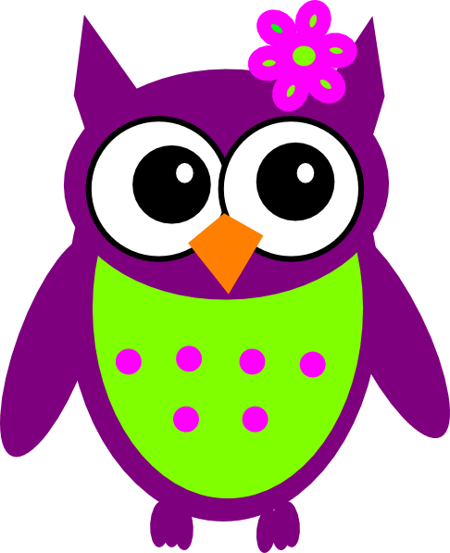

A STORY FOR ..... WRITTEN BY ......

Once upon a time there was a very busy small mouse who lived in the forest with all of her friends and family.


The forest was full of wonderful creatures who the mouse simply adored.

There was Harry the hedgehog who despite his prickles was full of fun and made everyone laugh.



Sidney the snake who slithered around the forest in and out of woodpiles playing hide and seek with mouse and the others.


Frank the fox was best at telling wonderful stories that made everyone look forward to the campfire each evening to hear another chapter of the exciting tales he told.



Life was good for mouse surrounded by the creatures she loved and trusted in her beautiful safe place.

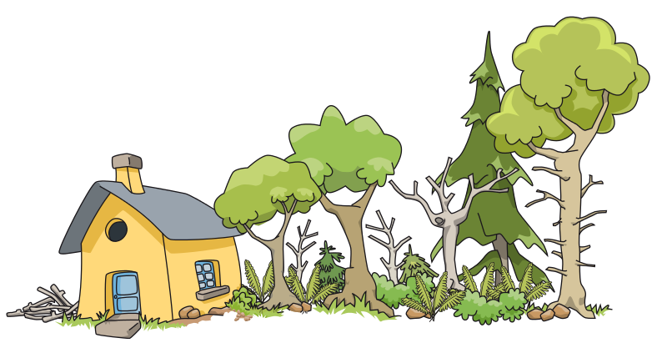

Then one day a terrible thing happened, a huge storm came to the forest. The wind ripped through the trees and hedgerows pulling them out of the ground. Then thunder and lightening hit them with a terrifying force.


The thunder was so loud and the lightening so scary as it hit the tress splitting them in two and setting them on fire.
Mouse was terrified and her family and friends ran off in all directions to find safety and to survive the awful storm.

When the storm was over Mouse peeped out from inside of her hidey-hole and found that nothing looked the same any more.



The forest was ruined and the world outside no longer seemed to be the beautiful place it used to be….IT WAS SCARY!



Her friends and family were nowhere to be seen.

Mouse found that when she found new creatures who wanted to take into their home to keep her safe and warm and to care for her she was scared and she fought and argued with them to try and keep them away from her. She thought that this was the way to keep herself safe.

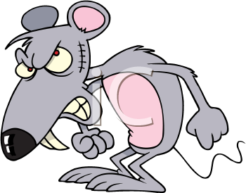

She soon found that the love and trust she had inside had disappeared. She was cross and angry and quite frankly hard to get along with !!!

Then one day a Magic Owl who had been watching over Mouse and seeing how sad and grumpy she had become since the storm swooped down from the tree and touched little mouse on her heart.



The Owls Magic opened a little pouch inside of Mouse to hold onto the tiny bit of Love that Owl had placed inside.

Mouse didn’t really understand how the Magic owl had touched her heart, but what she did know was she could feel the tiny bit of love inside beginning to grow. Slowly and steadily she stopped being so scared and allowed her new family to love and care for her. When she met new creatures she began to love and trust them just like she had done so before.

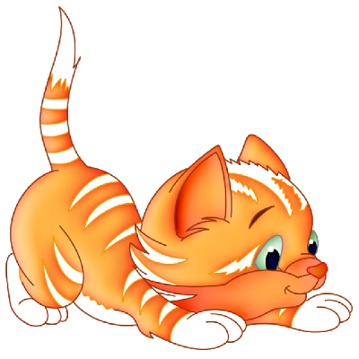
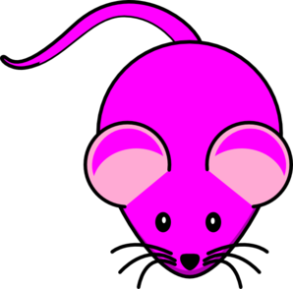

When Mouse realised how she was able to love and trust again she and her new family along with her new friends built a new and happy life together


THE END

