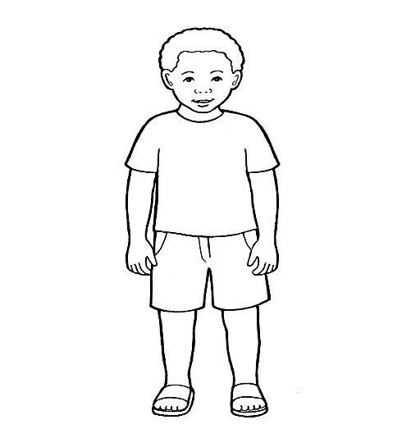

MY LIFE WITH MY GROWING UP FAMILY

To My “Growing up” Family,

Please use this book to describe my new family, each and everyone of its members, even the pets. The purpose of this book is to help me understand how did I come to live with you so that I can make sense of my present and future life.

Thank you!

Contents

1. What is a “Growing up” family?

2. What is my “Growing up” family like?

3. Moving to my “Growing up “family

4. My life now and in the future

5. Photographs

My Life with My Growing Up
Family



1. What is a “Growing Up” family?

When children can no longer live with their birth parents, social workers and the wise Judge have to make decisions about their future. In many cases, social workers spend time to choose a new family, one with parents who would be able to understand better what children need and who would know just how to look after children and keep them safe for a very, very long time - until they are all grown up!
We call this a “growing up” family “ and this book is all about ……………’s growing up family and how ………….came to live with them.

2. What is my “Growing up” family like?

Please describe what are the
favourite family activities and what makes the family enjoy time spent together?

Please name everyone within the family, their ages and what do they like/dislike?

Please describe the house and the area where you live.

Please attach pictures of the family, the house and your pets. These will help me learn about my “growing up” family before meeting them.

3. Moving to my “Growing up” Family

Please talk about how did you, as a family, get to find out about me? What were your first thoughts and feelings? Who did you talk to about me before you first met me?

Have you met any of my birth family members and if you did, how did that go and are there any photographs?

Please talk about the special moment when you first met me. How did that go and what did we do together?

Please talk about how did I say “Good Bye” to my foster carer and the journey to your house? What did I think of it when I arrived and what were your first thoughts about how I settled into my new family?

Please remember our first days together, what was I like and what did I enjoy doing?

4. My Life Now and in the Future

Please use this space to talk about our current life together, where do I go to school/nursery, favourite activities, favourite foods, what do we do together and what plans do we have for the future?

This is the space where you can continue adding information until I am a “grown up”. Please allow me the opportunity to contribute to this section in the book so it is our joined up effort.

5. Photographs

These are photographs of ………………….together with her/his “Growing Up” family. These photographs will help ……….. remember favourite family activities, important events, any anecdotes and milestones achieved.

Please insert photographs, in the
boxes below and add names/dates and the context of the photograph.

