MEMORIES FROM THE COURT GUARDIAN

To my Court Guardian,

Please use this book to record your observations and memories of the times when you visited me.
Your records will help me better remember my journey through life. Please also record here what do you remember from when you met my Birth Family.

Thank you!

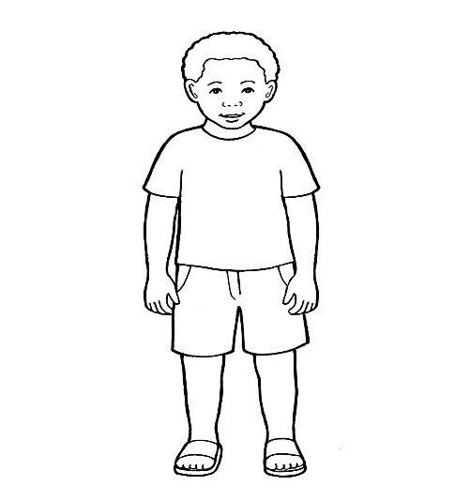

Memories from the Court Guardian

Contents
- What is a Court Guardian and what is their role in a child’s life?

- What was my relationship with my Court Guardian and what do they remember about me?

- What role did my Court Guardian have when decisions were made about my future?

- What does my Court Guardian remember about my birth family?

- What is a Court Guardian and what is their role in a child’s life?



A Children’s Court Guardian becomes involved when Social Services go to Court to ensure that children are kept safe. The Guardian is named by the Court and their role is to make sure that all decisions that are made for the child are in the child’s best interest.

- What was my relationship with my Court Guardian and what do they remember about me?

Please talk about yourself and how did you become involved in my journey ?

Please talk about the times when you visited me: where did we meet, how was our interaction, what did we talk about, what questions did I ask?

Do you remember any special occasions or meetings when we were together ? Please describe these and who else was there.

3.What role did my Court Guardian have when decisions were made about my future?

Please explain what did you do or say when decisions were made about my future?

Who did you talk to in order to reach your conclusions? Were there any disagreements and if so, why?
Please explain your views and opinions with regards to decisions made about my future and how were you able to influence these?

4.What does my Court Guardian remember about my birth family?

Who did you meet from my birth family? How was your relationship with them?

Can you please describe your own observations of my birth family and of my relationship and interaction with them?

Did you observe any visits between me and my birth family? What were your observations ?

What was your opinion about the care that I had been given by my birth family? Did you talk to me about that and how did you explain the events from Court to me?

