MEMORIES FROM THE Independent Reviewing Officer

To my IRO,

Please use this book to record your observations and memories of the times when you chaired my Review Meetings.
Your records will help me better remember my journey through life. Please also record here what do you remember from when you met my Birth Family and Foster Family.

Thank you!

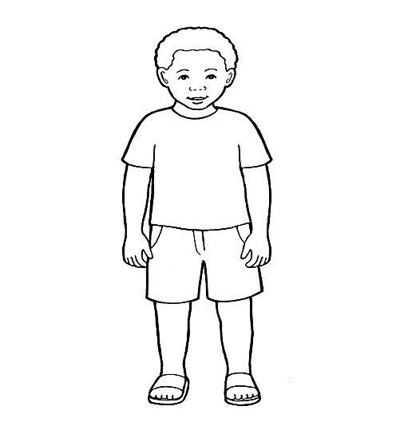

Memories from the IRO

Contents

- What is an Independent Reviewing Officer and what is their role in a child’s life?

- What was my relationship with my IRO and what do they remember about me?

- What role did my IRO have when decisions were made about my future?

- What does my IRO remember about my birth family and my foster family?

- What is an Independent Reviewing Officer and what is their role in the life of a child looked after?

An Independent Reviewing Officer (IRO) is a professional person whose role is to ensure that all actions taken by Social Services are right for the child and that the child’s wishes and feelings are listened to. An IRO becomes involved when a child is taken into care by Social Services and becomes a Looked After Child. An IRO chairs meetings between all professionals, birth and foster family and they recommend what more needs to be done in order for the child’s needs to be met.



- What was my relationship with my IRO and what do they remember about me?

Please talk about yourself and how/when did you become involved in my journey ?

Please talk about the times when you chaired my Reviews: where were they held, who usually attended, did I take part in the meetings, what did we talk about, what questions did I ask?

Were there any special occasions/incidents/ anecdotes that you remember from my Reviews?

3.What influence did my IRO have when decisions were made about my future?

Please explain your views and opinions with regards to decisions made about my future and how were you able to influence these?

Who did you talk to in order to reach your conclusions? Were there any disagreements and if so, why?

4.What does my IRO remember about my birth family and my foster family?

Who did you meet from my birth family?

Can you please describe your own observations of my birth family and of my relationship and interaction with them?

What do you remember about my foster family? Who did you meet from my foster family?

What do you remember about my relationship with my foster family ?

