SPENDING TIME WITH MY BIRTH FAMILY

To the Supervisor of my visits with my Birth Family,

Please use this book to record your observations and memories of the time I spent with my Birth Family whilst living in Foster Care.
Your records will help me better remember these special occasions. Please also take photographs of the activities I enjoyed doing with my Birth Family and make sure you write down who is in the picture.

Thank you!

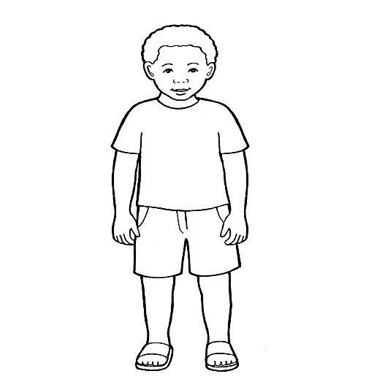

1. Spending Time with my Birth Family—what does it mean, when, where and who takes part?

2. Photographs

Spending Time with my Birth Family

Contents

1. Spending Time with my Birth Family—what does it mean, when, where and who takes part?


Children who live with foster carers regularly spend time with their birth family. This is usually organised away from the foster carers’ home, at a family centre or out in the community and is usually supervised by a support worker whose job is to make sure children remain safe at all times and they get to enjoy their time with their birth families.

How often did I get to see my family after I came into care?

Who did I used to see at family time? Who supervised our visits?

Where did I used to see my family? If in a contact centre, please describe it so I can remember it better.

How was I when I met my family and how were they? What about endings?

Did we celebrate special events such as birthdays and Christmas and how did that go?

What activities did we do together and what did I enjoy the most?


2.Photographs

These are photographs taken when ……...used to see his birth family. These photos will help ……………..remember her/his birth family and the time they spent together whilst he/she lived in foster care.

Please use the boxes below to insert photographs and write the name of who is in the picture, the date when the picture was taken and the context around it.

