MY LIFE WITH MY
FOSTER FAMILY

Dear foster family,

Please use this book to record my life with you. These are memories which I will later on treasure and you are so very important in helping me keep them, so they are not lost forever. Please take time to answer all my questions and imagine how pleased I will be reading this book in years to come.
If you don’t have the answer to some of the questions because of the age I was when I came to live with you, that is ok. You might want to mention other milestones I achieved whilst in your care, such as being able to express my emotions in a positive way or having my first sleepover.
Please remember to add the date and names of everyone in the pictures you are using in part 9 of the book.
Thank you!

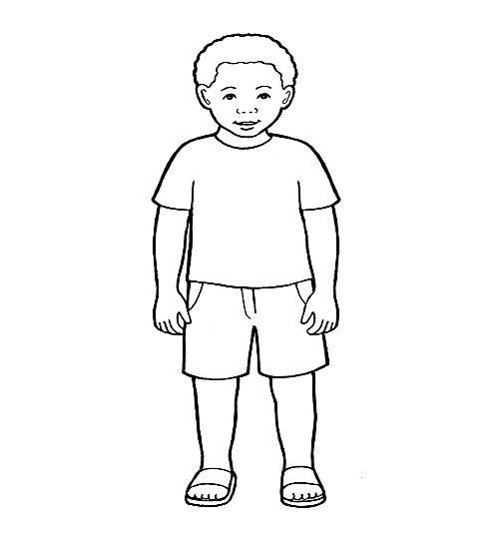

My Life with My Foster Family
Contents

1. My Foster Carers and their Home

2. Milestones

3. My nursery and school years

4.School reports /achievements and certificates from after school clubs and sports

5. Celebrating birthdays and going on holiday

6. Memorable moments

7. Any accidents/illnesses/times spent in hospital

8. Funny moments/anecdotes

9. Photographs

9. Photographs

1. My foster carers and their home

When children can no longer live with their birth families, they can usually go to a foster family. Foster families look after children and keep them safe. Sometimes they look after children for a short time and sometimes they look after children for a long time.



When did I come to live with you and who brought me? How old was I at the time and what were the things that I could do?
0

Were there other foster children placed with you when I arrived? Were they older or younger than me? How was my relationship with them?

Which area did you live in at the time and who lived in the house? Did you have any pets?

Tell me what do you remember from my first few days I spent with your family?

2. Milestones I achieved whilst living with my foster carers

How was my sleep routine when I first arrived and how did that change during the time I lived with my foster family?

How was I feeding and who did usually feed me ?

What comforters did I use for going to sleep and for when I became upset or sad?

What do you remember about my bath time? Who used to bath me, did I enjoy it, did I have favourite bath toys?

When did I have my first tooth and which tooth came out first? How was I during the teething months as a baby?

How old was I when could I sit up
unaided, for the first time ?

When did I first stand alone, with no help ?

What age was I when I started to crawl?

When did I take my first steps without any help ?

What were my first words and when did I say them? What do you remember about the time when I started babbling, speaking and singing?

When and where did I get my first pair of shoes ?

What solid food did I first have and how did I enjoy that? What were my favourite meals and when did I start eating by myself?

Did I prefer to pick objects up with my left or my right hand?

When did I start using a feeder cup by myself and what was my favourite drink?

What were my favourite toys and games ?

Did I enjoy swimming and if so, who used to take me swimming?

What age was I when I first could ride a scooter or a bike? Who helped me learn how to ride them?

What books did I enjoy being read to me and who used to read my bed time story? Did I have a favourite character?

How did I get on with becoming more independent, such as washing/getting dressed/eating by self?
What about potty training?

3. My nursery and school years

What baby and toddler groups did I go to? Did I enjoy these and what used to be my favourite
activity/toy/nursery rhyme whilst there?

Where did I go to school ? When did I start school and how was my school life like? Who were my teachers and who were my friends? Did I enjoy any particular subjects?

Where did I go to playgroup/preschool and who was my teacher? Did I make friends whilst there and was I happy going ?

Did I do any afterschool activities and if so, which activities did I enjoy the most?

4. School reports /achievements and
certificates from after school clubs and sports

Please provide summary of achievements and attach certificates/reports from school and out of school activities!

5. Celebrating birthdays and going on
holiday

How did we spend holidays and how did I react to going on holiday? Have I ever been on an airplane or in a caravan?

How did we celebrate my birthdays and what special presents did I receive? Who used to attend my birthday celebrations and what did I enjoy doing?

6. Memorable moments

Remember events that were really special in my life (eg. Christening, managing a certain task independently for the first time, choosing a pet, first sleepover, participating in a charity event, etc)

7. Any accidents/illnesses/times
spent in hospital?

Did I have any accidents/injuries/illnesses for which I needed to be treated in hospital? How did I manage that?

Did I have chickenpox or any other childhood illness, how did I manage that and what helped me feel better through it?

8. Funny moments/anecdotes

Please record any anecdotes, things that I used to do and which made you or the family laugh.

9. Photographs

These are photographs taken by ……………….’s foster family. These will help ……………….remember her/his life with …………………..

Photographs of the foster home and the foster
family including pets and extended family members

Photographs of my developmental
milestones

Nursery/School photos and photos from after school clubs/ extra curricular activities/teachers and friends

Photographs from birthday celebrations, parties and holidays

Photographs from memorable events

