MY LIFE WITH MY

BIRTH FAMILY
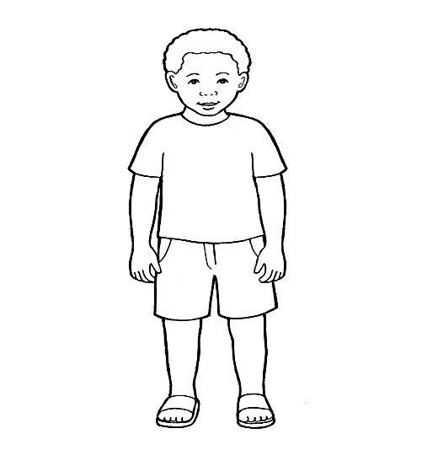

To My Social Worker,

Please record here all the information that you can gather about my life with my birth family, before coming into care.
Please give the first two parts of this book to my birth parents. I am hoping they would take the time to fill the book in with lots of lovely information. If this can not happen for various reasons, then please try to engage them or any other of my birth family so that you can include lots of really valuable information for me to read later on.
The purpose of this book is to help me understand my life whilst living with my birth family and to make sense of the circumstances that led to me coming into care.
Thank you!

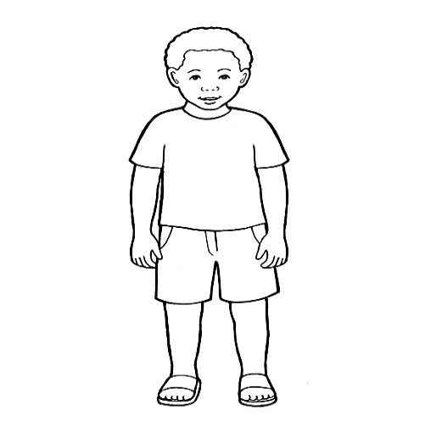

My Life with My Birth Family

Contents

1. My birth parents and my birth

2.My life with my birth parents

3.Why I could no longer live with my birth family

4. Photographs

1.My birth parents and my birth


A birth family is the family you have when you are first born.

Everyone has a birth mum and a birth dad, even if they don’t see them or live with them.

What were the names of my birth parents and what did they look like?

How and where did my birth
parents meet each other? How was their relationship like?

What do you know about my birth parents life before they met each other (childhood, education, jobs, other relationships)?

How many children did my birth parents have and what were their names?

Where did my birth parents live? Who lived with them in the house?

What do you know about the time when my birth mother was pregnant? Did she seek any medical help, was she healthy and were there any significant events during that time?

When and where was I born? What day of the week it was? Did I arrive on time or not? How was the birth? What about my weight and health at birth?

What name did my birth parents choose for me and why?

2. My life with my birth parents

Families come in all different shapes and sizes. This is the story of …….’s life with birth parents………. and ……….. Like all stories, it has happy parts and not so happy parts.

Where and who did I live with? Can you describe the house I lived in and all the people I lived with?

Were there any other family members I used to see? What were their names and where did they live?

Did my birth family think I looked similar to any particular family member? If so, in which way ? What about personality, likes and dislikes? Any similarities there?

How was my sleep routine when I lived with my Birth Family ?

What comforters did I use for going to sleep and for when I became upset or sad?

How was I feeding and who did usually feed me ?

Were there any significant events in my life which my birth family can remember and talk about?

What do you remember about my bath time? Who used to bath me, did I enjoy it, did I have favourite bath toys?

When did I have my first tooth and which tooth came out first? How was I during the teething months as a baby?

How old was I when could I sit up
unaided for the first time ?

What age was I when I started to crawl?

When did I first stand alone, with no help ?

When did I take my first steps without any help ?

When and where did I get my first pair of shoes?

What were my first words and when did I say them? What do you remember about the time when I started babbling, speaking and singing?

Did I prefer to pick objects up with my left or my right hand?

When did I start using a feeder cup by myself and what was my favourite drink?
What solid food did I first have and how did I enjoy that? What were my favourite meals and when did I start eating by myself?

What were my favourite toys and games ?

What age was I when I first could ride a scooter or a bike? Who helped me learn how to ride them?

Did I enjoy swimming and if so, who used to take me swimming?

What books did I enjoy being read to me and who used to read my bed time story? Did I have a favourite character?

How did I get on with becoming more
independent such as washing/getting dressed/eating by self?
What about potty training?

Did I have any favourite foods, games, toys?

Who in the family I spent more time with and who mostly cared for me?

Did my birth family think I looked similar to any particular family member? If so, in which way ? What about personality, likes and dislikes? Any similarities there?

Did I go to any childcare/nursery or school ? If so, where did I go? What do my birth family remember about me going to school or nursery? Did I enjoy it and did I make friends?

What about my teachers in school/nursery? What were their names and what were my favourite
teachers?

Did my family have any pets? If so, what were their names and what was my relationship with them like?

What were my favourite
activities/sports/hobbies as I was growing up? What did my birth family think of how well I did in some of these activities?

Were there any significant events in my life which my birth family can remember and talk about?

What about any anecdotes and funny things my birth family remember about me from when I lived with them?


3. Why I could no longer live with my birth family

Children need lots of care and not just some of the time but all of the time - EVERY DAY!

Bringing up children is like building a wall!

Bringing up children is a bit like building a wall!
To make tall, strong walls you need a very good foundation and then, using just the right amount of cement, you carefully lay all the different bricks on top.

The cement is like the love that holds everything together and makes the walls strong. Children need love but they also need lots of different kinds of caring to help them grow properly and they need to be cared for by grownups who can make sure that children are happy, healthy and safe.

What were the “bricks” in this wall which my birth parents could not “lay” for me and why? What were the “bricks” they were able to put down for me?

How did that make me feel and how did it impact on my life?

Who were the people who
became concerned about me and what did they do to help my birth parents care for me better?



Social Workers are people who make sure that children are well looked after by their families. They visit the homes of children who they are worried about, speak to the children and their families and then check things out with other people such as nurses, teachers and Police.

If they are really worried, they try and help out by sending help to the house or teaching the parents how to look after their children and how to get along better.

Unfortunately, things don’t always go to plan and sometimes social workers have to ask Judges if they thought children could continue living with their families.

The Judge is a really wise person who knows a lot about children and families and they can make decisions about children no longer living with their birth families.



Who was(were) my social worker(s), what was her/his (their) name and what does she (they) remember about me?

What happened that made social workers and the Judge decide I could no longer live with my birth family?

When and where did I go ? Who was with me and what does my social worker remember about the move?

What help and support did my birth parents have whilst I lived with foster carers?

Were there any important events that happened for my birth family whilst I lived in foster care?

Did my birth parents get to see me whilst I lived in foster care?

What happened to my siblings and any other family members whilst I lived in foster care?

Where there any decisions made about my future whilst I lived with foster carers? What decisions were these and who made them?

If decisions were made that I could no longer live with my Birth Family– did I get to see them for the last time before moving on?

If a final visit with my Birth Family was arranged, how did that go, what did we do together and who was present?

4. Photographs

These are photographs of ……………… and his/her birth family as well as places where ……….lived with her/his birth family. Each photograph is dated and is accompanied by a brief explanation of who is in the photo, the date when it was taken and what happened. This is where photographs of social workers involved with the family can be included.

Figure 1 Insert pictures here

Figure 2Insert comments here

Figure 3Insert pictures here

Figure 4 Insert comments here

