A list of books for children to help with their feelings and emotions
- A Safe Place for Rufus by Jill Seeney
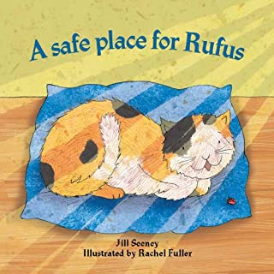

- Sharing a Shell by Julia Donaldson
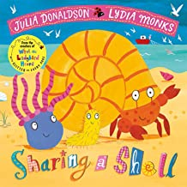

- The Butterfly Inside by Serena Lane Ferrari
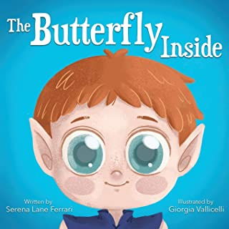

- Sophie Spikey by Sarah Naish
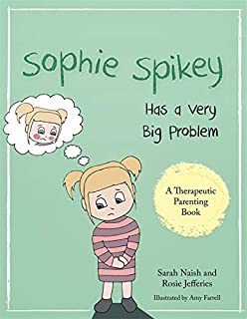

- Charley Chatty by Sarah Naish
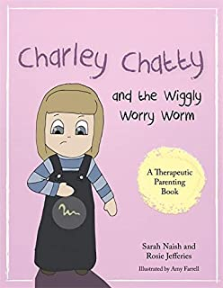
- Listening with my Heart by Gabi Garcia
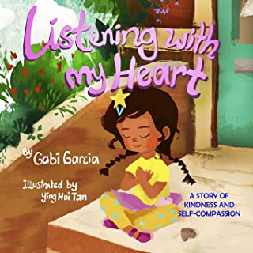
- Dennis the Duckling series by Paul Sam Brook

- Dennis duckling
- Dennis and the big decision
- Dennis lives with Grandma and Grandpa
- Dennis goes home
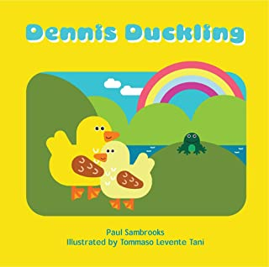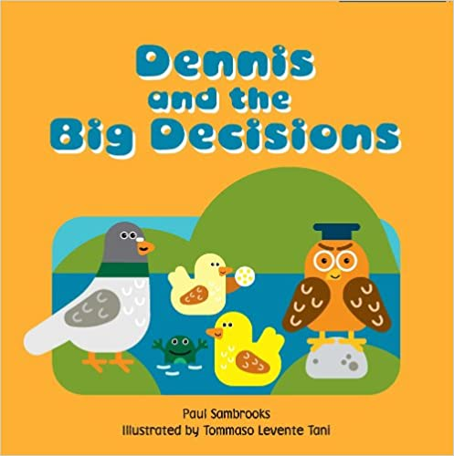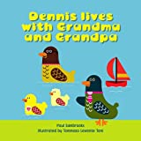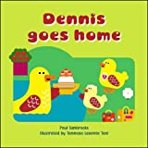

- The Invisible String by Patrice Karst
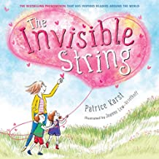

- Always and Forever by Alan Durant
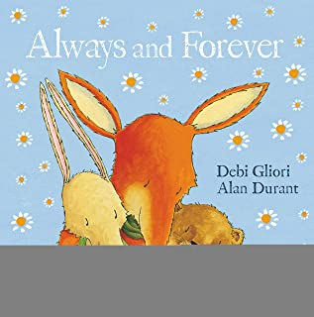

- Listening to My Body by Gabi Garcia

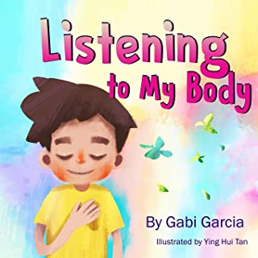
- You’re a Star by Poppy O’neill
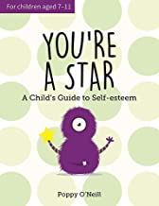

- Sometimes, I’m Anxious by Poppy O’neill
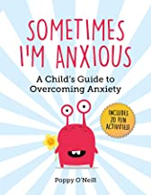

- Daddy, Papa and Me by Leslea Newman
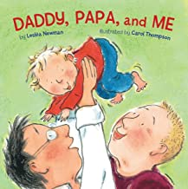

- Mammy, Mama and Me by Leslea Newman
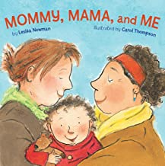

- Ruby’s Worry by Tom Percival
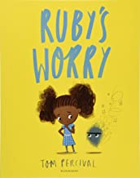

- My Shadow is Pink by Scott Stuart
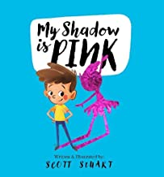

- The Lion Inside by Rachel Bright & Jim Field
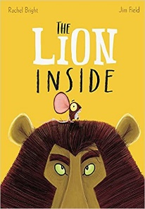

- My Hidden Chimp by Professor S. Peters
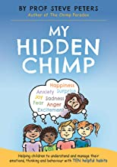

- The Boy at the Back of the Class by Onjali Rauf

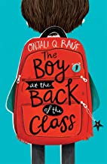

- Nutmeg collection by Judith Foxon

- Nutmeg Gets Adopted
  - Nutmeg Gets Cross
  - Nutmeg Gets A Letter
  - Nutmeg Gets A Little Help
  - Nutmeg Gets into Trouble
  - Nutmeg Gets A Little Sister
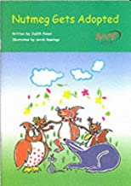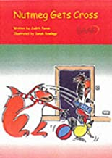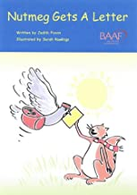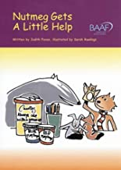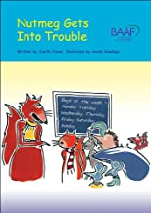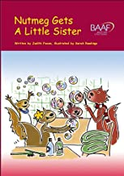

- Chester and Daisy move on by Angela Lidster
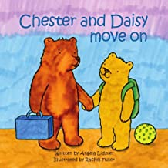

- It’s ok to be Different by Sharon Purtill
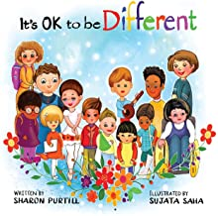

- The Proudest Blue by Ibtihaj Muhammad
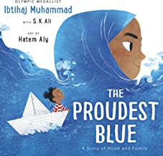

- The Day you Begin by Jacquelin Wilson
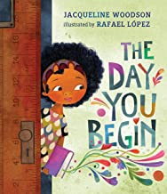

- The Most Precious Present in the World by Becky Edwards
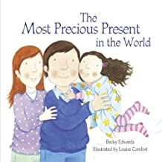

- Where is Poppy’s Panda? by David Pitcher
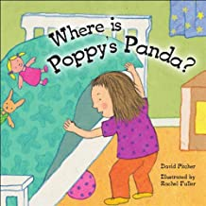

- Elfa and the Box of Memories by Michelle Bell
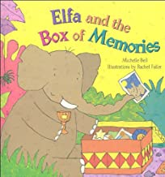

- Tyler’s Wishes by Helen Kahn
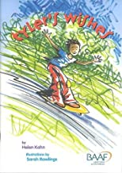

- Morris and the Bundle of Worries by Jill Seeney
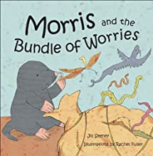

- Not Again, Little Owl by Dr. Vivien Norris
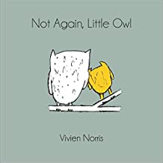

- William Wobbly by Sarah Naish
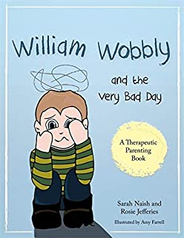
- The Very Wobbly Christmas by Sarah Naish and Rosie Jeffries
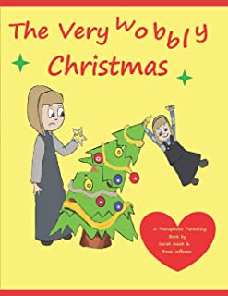
- Sometimes I feel Sunny by Gillian Shields
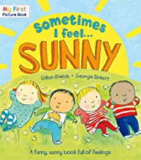

- My Many Coloured Days by Dr. Seuss
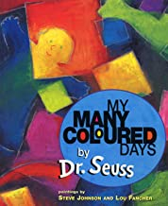
- The Huge Bag of Worries by Virginia Ironside

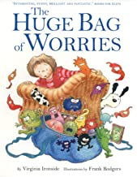
- The Girl Who Never Made Mistakes by Mark Pett & Gary Rubenstein
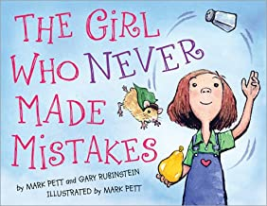

- The Very Hungry Caterpillar by Eric Carle
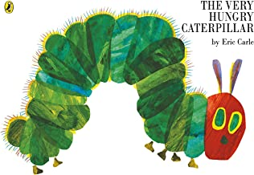

- The Goodnight Caterpillar by Lori Lite
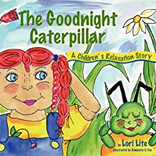

- The Story of Tracey Beaker by Jacqueline Wilson
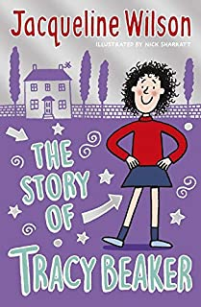

- Margot Sutherland books

- Teenie Weenie in a Too Big World is a story for fearful children
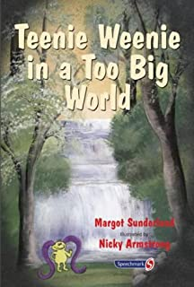

- A Wibble Called Bipley is a story for children who have hardened their hearts or have become bullies
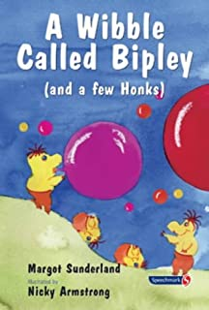

- How Hattie Hated Kindness is a story to help children who are locked in rage or fear
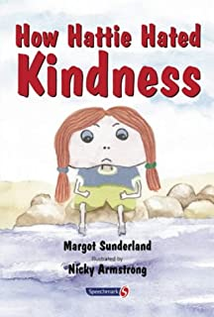

- A Pea Called Mildred is a story to help children pursue their hopes and dreams
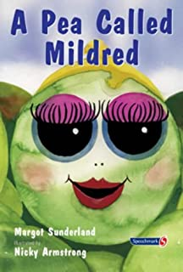

- Monica Plum’s Horrid Problem is a story to help children of troubled parents
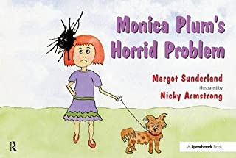
- A Niflenoo Called Nevermind is a story for children who bottle up their feelings
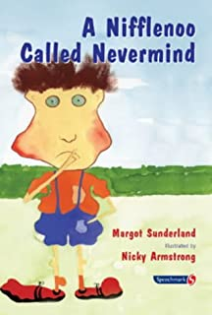

- The Day the Sea Went Out and Never Came Back is a story to help children with loss
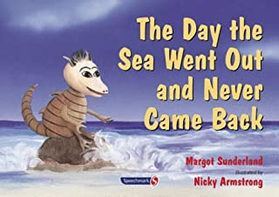

- Willy and the Wobbly House is a story for children who are anxious and obsessional
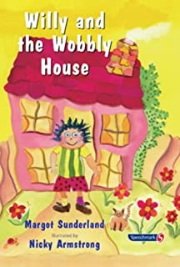

- The Frog who Longed for the Moon to Smile is a story to help children who yearn for someone they love
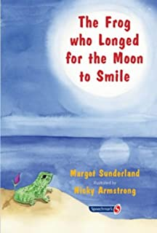

- Ruby and the Rubbish Bin is a story for children with low self-esteem
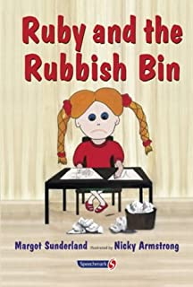

41.Hair in Funny Places by Babette Cole
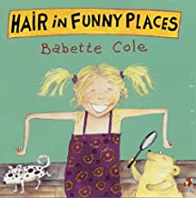

42.What’s happening to me? by Susan Meredith
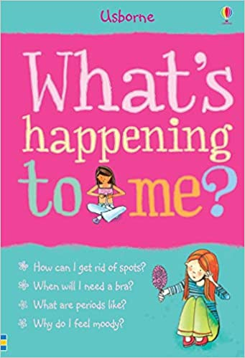

43.Help Your Dragon Deal with Change by Steve Herman
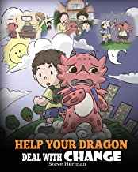

44.The Mindful Dragon by Steve Herman
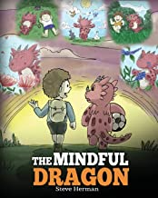
45. Therapeutic stories for children 5-10 years by Dr Karen Treisman
- Neon the Ninja
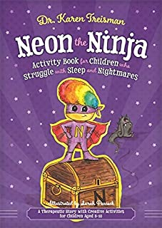
- Cleo the Crocodile
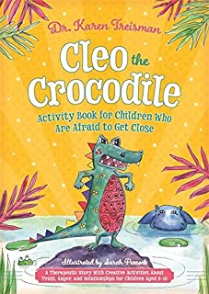
- Gilly the Girraffe

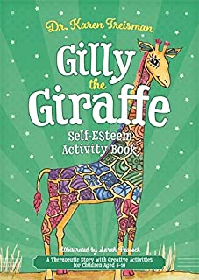
- Presley the Pug
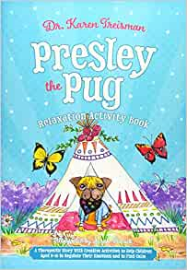

46. We’re Going on a Bear Hunt by Michael Rosen
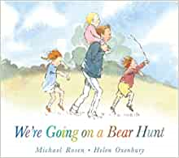

47.The Magic Precious Rosebush by Joy Rees

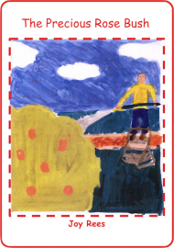

48. Finding a Family for Tommy by Rebecca Daniel

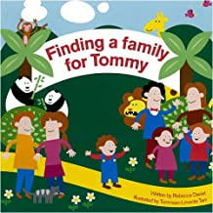

49.Murphy’s three homes by Jan Levinson Gilman

