This is Evan’s Story



This is the story of a very special little boy called Evan. Evan lives with his Mummy and Daddy, and they love Evan very, very much.

Here they all are!



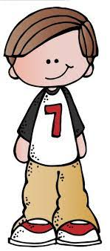

Evan hasn’t always lived with his Mummy and Daddy.

Evan first lived with his foster carers June and John and their boys Aiden and Jim.

This is June and John and Aiden and Jim.




All babies first grow in their birth mummy’s tummy. Everybody in the whole world has a birth mummy. You need a birth mummy and a birth daddy to make a baby.

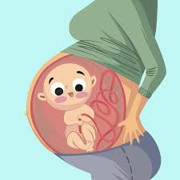

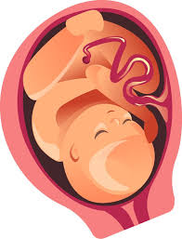
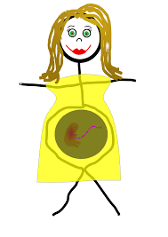

Evan’s birth mummy is Katherine and Evan first grew in Katherine’s tummy.
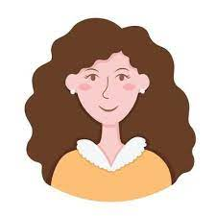

Evan’s birth daddy is Trevor.


Katherine and Trevor are Evan’s birth parents.
Evan was born at 6pm on Tuesday the 1st August 2016 in Singleton Hospital which is in Swansea.

This is Singleton Hospital.


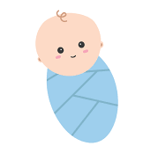

Swansea is a city beside the sea in South Wales. It has a big beach called Swansea Bay. Singleton hospital is right by the beach, and you can see the sea when you look out of the windows.


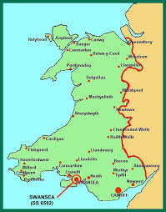


When Evan was born the midwife weighed him on a special weighing scale. He weighed 7 pounds and 7 ounces. This is about as heavy as three and a half bags of sugar!



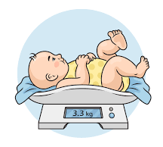

Evan was a very beautiful baby. Trevor was there with Katherine when Evan was born. Katherine and Trevor both said that they were very excited when they first saw Evan. They said that Evan was a very handsome baby and they felt very proud. Evan had to stay in hospital for four days after he was born as he had jaundice and needed special medicine to make him stronger and feel better. The nurses helped Katherine to look after Evan. Katherine gave him bottles of milk and she changed his nappy. Katherine gave Evan lots of cuddles.
Look at Evan! Here he is with Katherine after he was born in the hospital. Evan was such a cute baby!
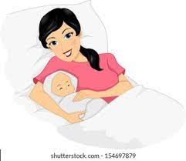



When baby Evan came out of the hospital, he went to stay with June and John. June and John are foster carers. Foster carers look after children that can’t live with their birth parents.
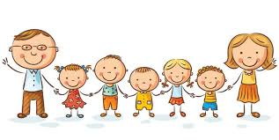

June and John loved having Evan stay with them. Here are photographs of baby Evan with June and John on the 5th August 2016 which is the day he first came to live with them! Look how tiny and cute he is!


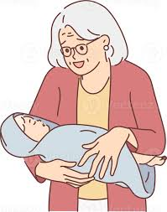


Katherine had four other babies grow in her tummy before Evan. They are Evan’s brothers and sisters. Their names are Chester, Sarah, Nia and Dilwyn. Chester was the first baby to grow in Katherine’s tummy, so he is the oldest. Evan is the youngest. Trevor is not Chester, Sarah, Nia or Dilwyn’s birth father. Their birth fathers name is Paul. Trevor is just Evan’s birth father.

Chester lives with Uncle Darren and Auntie Gill. Uncle Darren is Katherine’s big brother.


Sarah, Nia and Dilwyn live with Nanny Julie. Nanny Julie is Katherine’s mummy.


There once was a time when Chester, Sarah, Nia and Dilwyn all lived together with Katherine and Trevor in a house in Swansea. This was before Evan was born.


Katherine loved all her children, but she found it hard to look after them properly and keep them safe. Katherine and Trevor would shout and fight with each. Katherine felt sad that Trevor shouted at her and she sometimes worried that he didn’t love her anymore. When Katherine felt sad, she would forget to give Chester, Sarah, Nia and Dilwyn food to eat and she didn’t take them to school. This made Chester, Sarah, Nia and Dilwyn feel very sad, hungry and scared.



Trevor would drink lots of beer every day. Beer is made with alcohol. Alcohol can make people feel happy or sad when they drink it. Trevor might have wanted to drink beer to help him feel happier, as he would sometimes feel sad. When Trevor drank too much beer, he would feel tired and cross. Trevor would get angry and shout at Katherine. Trevor also shouted at Chester, Sarah, Nia and Dilwyn.



Chester, Sarah, Nia and Dilwyn felt scared of Trevor after he drank beer.




One day something very bad happened. Trevor drank lots of beer and got very angry, and he hurt Chester. He shouted and hit him lots of times. Chester was scared and ran to his friend’s house and his friend’s mum was very worried and called the police.


A social worker came to speak with Chester. Her name was Jenny.



Social workers have a very important job to do. They make sure that children are safe and not in danger from the people that are caring for them. Jenny was very kind. She was worried when she saw Chester and heard about Katherine and Trevor shouting, arguing and fighting with each other.



Babies and children need to be looked after and kept safe.

Here are some of the things they need.

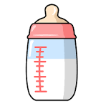
Babies need to be fed milk and the bottles to be clean need to be clean and sterilised.

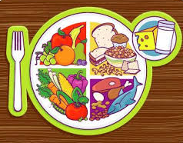
Children need to be fed healthy food so they that can grow big and strong.

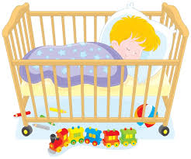
They need a clean, warm cot or bed sleep to sleep in.
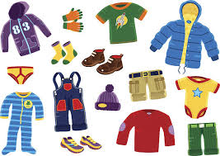

They need clean clothes that
keep them warm in the winter
or cool in the summer.

Babies and children need to be bathed
and kept clean. Babies need to have
their nappies changed so they don’t
get sore bottoms.

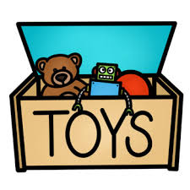
They need toys to play with,
this helps them to learn.

Babies and children need to be taken to see a doctor when they are ill. They also need help brushing their teeth and to be taken to the dentist to make sure their teeth are strong, clean and healthy.
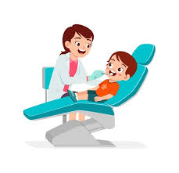
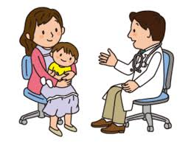


They need to be taken to school
every day.

Babies and children need a
warm, safe and clean home
to live in.

They need to be loved and cuddled, and they need the grownups that look after them to be kind, gentle, and safe.


So, as you can see there are lots of things that babies and children need. Can you think of any more things?

Jenny spoke with Katherine and Trevor, and she told them how worried she was. It was decided that Chester should stay with Uncle Darren and Auntie Gill, and Sarah, Nia and Dilwyn should stay with Nanny Julie.


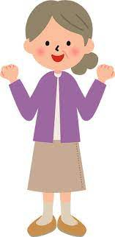

Katherine told Jenny that she had a baby in her tummy and that Trevor was the baby’s daddy. The baby in Katherine’s tummy was Evan. This made Jenny very worried that little baby Evan would not be safe inside Katherine’s tummy with all the shouting and fighting going on.
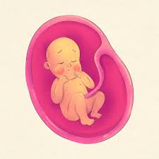

Jenny tried very hard to help Katherine and Trevor to learn about how to look after children properly and keep them safe. She also tried to help Trevor with his sad and angry feelings and tried to help him to stop drinking beer.

Unfortunately, Katherine and Trevor found it hard to learn how to look after children. Some people find it easy to learn how to be a mummy or daddy, some people find it hard. Trevor couldn’t stop drinking beer, it is hard to stop drinking beer when you have been drinking it for so long. Katherine and Trevor still felt sad, and they argued and had fights with each other. Jenny tried her best to help them.

Jenny needed to go to court to see a judge. Judges are very clever, and they work in courts. Judges decide where children should live when it is dangerous for them to live with their birth family.



Jenny told the judge all about Chester, Sarah, Nia and Dilwyn and about baby Evan who was in Katherine’s tummy.

The judge was very worried.

Babies and children find it frightening and confusing if they are brought up in a home where the adults get angry, shout or fight. It is wrong for a daddy to hit a mummy, or for a mummy to hit a daddy. It is wrong for a mummy or daddy to hit a child.




Jenny told the judge about how happy and safe Chester was living with Uncle Darren and Auntie Gill.


She also told the judge about how happy and safe Sarah, Nia and Dilwyn were living with Nanny Julie.
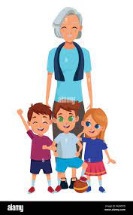

The judge had a very important decision to make.

The judge decided that it was not safe to let any of the children live with Katherine and Trevor. The judge decided that Chester, Sarah, Nia and Dilwyn should stay living with Uncle Darren, Auntie Gill and Nanny Julie because they were safe and happy.

But what about Evan?

The judge said that Katherine and Trevor would not be able to keep a baby safe and that it would be dangerous to let Evan live with them. The judge decided that Evan should be adopted and asked Jenny to find a new family for Evan.
Adoption means a new family is found for you when you can’t live with your birth family. When you are adopted, you legally become part of a new family forever, where you will be loved and kept safe.

Jenny searched for the right family for Evan.
Katherine and Trevor wanted Evan to come home with them and they felt sad the judge said he couldn’t. Jenny helped them to say goodbye to Evan and they made a lovely book of special photos and memories that Evan could keep forever and remember them.

Katherine and Trevor still think about Evan, but they know that he is safe, loved and happy in his new family and that makes them feel happy too.

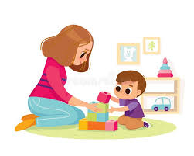

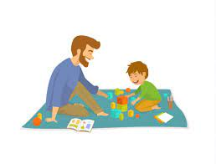

Jenny searched very carefully for the right family for Evan. Eventually she found Maggie and Sam, and she told them all about Evan. Maggie and Sam knew straight away that they wanted Evan to be part of their family.

Evan met his Mummy and Daddy on the 4th March 2018. They came to June and John’s house, and they all went to the park together. They had so much fun! Here are some photos of that special day.

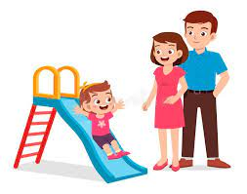



June and John loved having Evan live with them. Evan had lots of toys, cuddles, trips out, good food, a warm bed, clean clothes and all the things he needed to grow and be safe and happy. June said that,

“Evan was a beautiful baby; he slept really well and loved his food! His favourite was custard and ice cream, and he liked bananas too. Evan enjoyed watching Mr Tumble and Paw Patrol on the telly and we would have lovely little holidays in our caravan. His favourite toys were his musical instruments and oh what a noise he would make with them! Evan’s first word was dadda, and he first started to walk when he was twelve months old, not long after his first birthday! Evan liked having cuddles and he was such a chatterbox! We loved having him stay with us and we missed him when he left. We were so happy when Jenny found him his lovely Mummy and Daddy. We knew as soon as we met them that they would be wonderful for Evan and that they would love him so much.”

Evan moved to live with his Mummy and Daddy in April 2018.


Evan’s story doesn’t end there of course! Evan has so many more amazing adventures yet to come and he will make many more special memories with his Mummy and Daddy. I wonder what he will get up to! I am sure he will grow up to be very big and clever and will be loved by all his family.



