EARNIE AND EDDIE
THE TWO LITTLE BEARS.

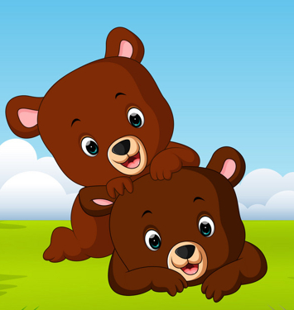

There was once a family of bears.
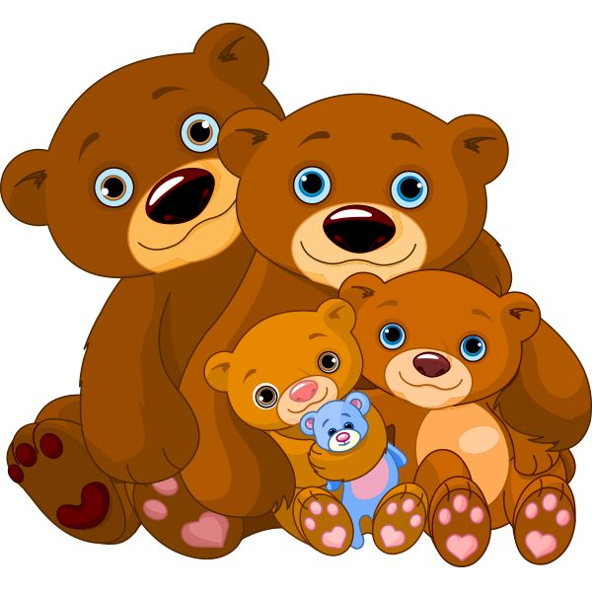
There was mummy bear, daddy bear and two little bears called Ernie and Eddie.

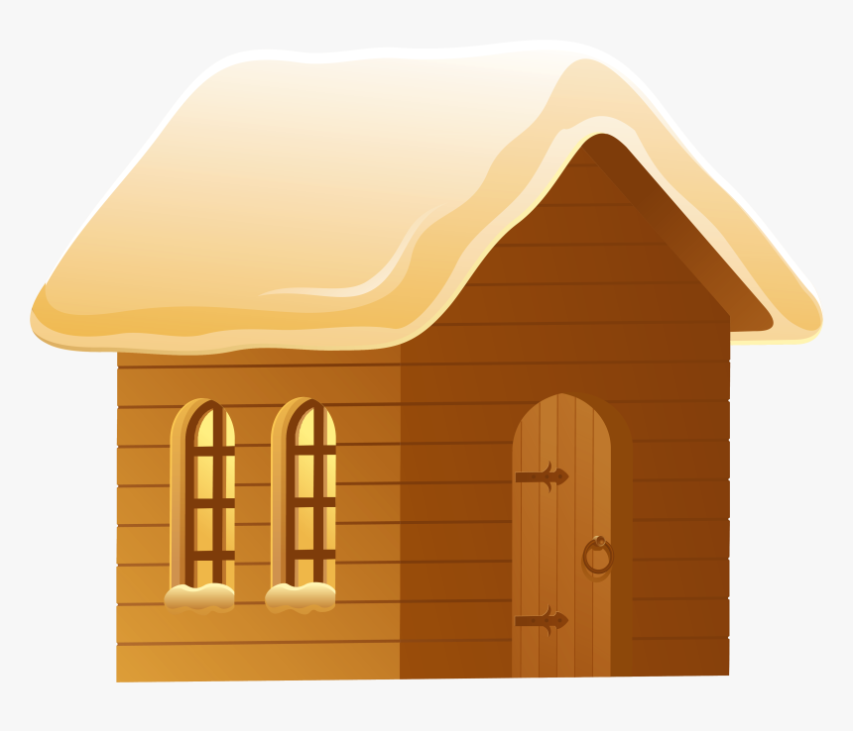

They all lived together in a little wooden house.

Big brother Earnie loved playing with bear toys,

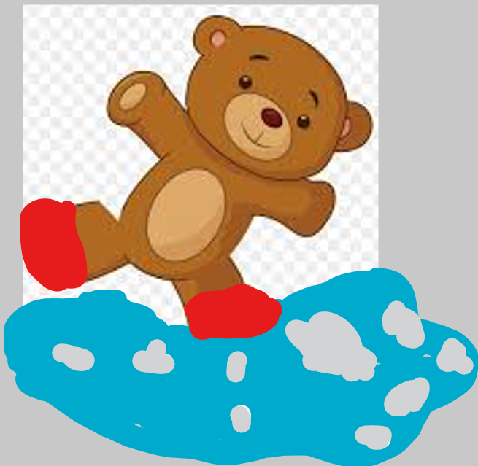
and jumping in big muddy puddles.

Little brother Eddie was only a baby bear he liked to drink his bear juice,
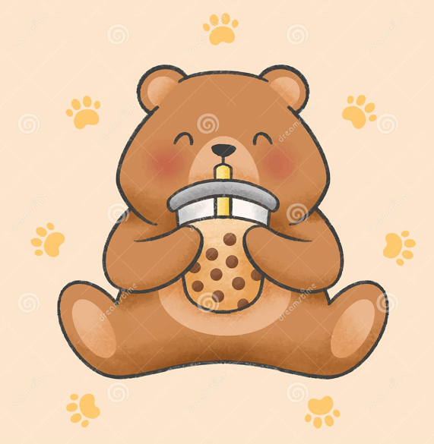
and take bear naps.
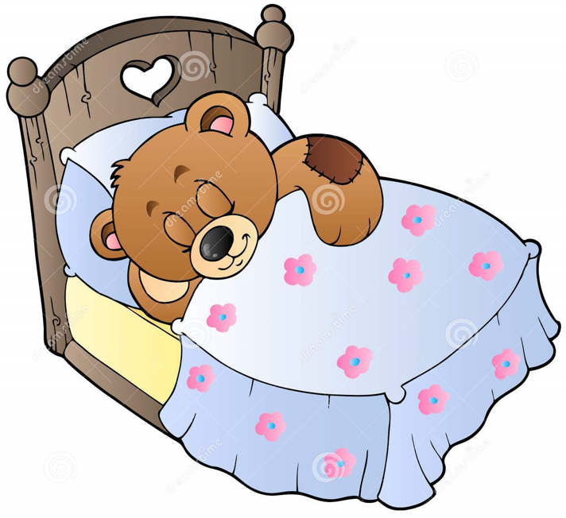
Both little bears loved playing and having lots of cuddles with mummy and daddy bear.

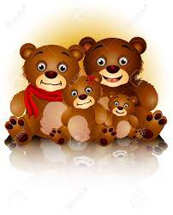
Mummy and daddy bear had met when they were young bears; they had only just started to learn how to look after themselves, and at times found it hard to take care of the two little cubs.

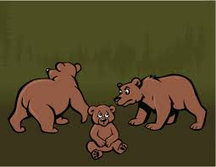

They did not always know how to take care of their two busy bears, and would forget how important being mummy and daddy was for the two little boys to grow up in a home that kept their little cubs safe.

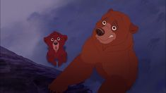
One day mummy bear was worried about little Eddie, his fur was all lumpy.

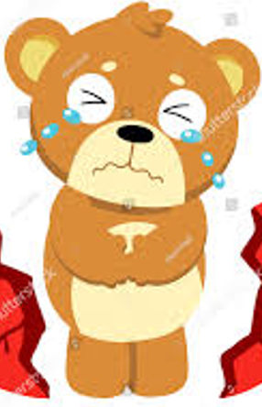

Mummy and daddy took him to the animal hospital to see Dr Owl.



Dr Owl took a good look at Eddie’s fur from the top of his fury ears to the bottom of his furry toes; he even took a picture of inside his tiny bear body.
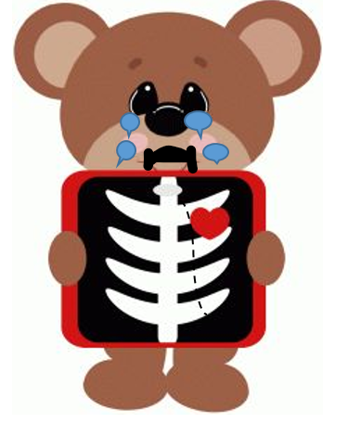

Dr Owl was worried that little Eddie’s fur was all lumpy because his bones were hurt inside.
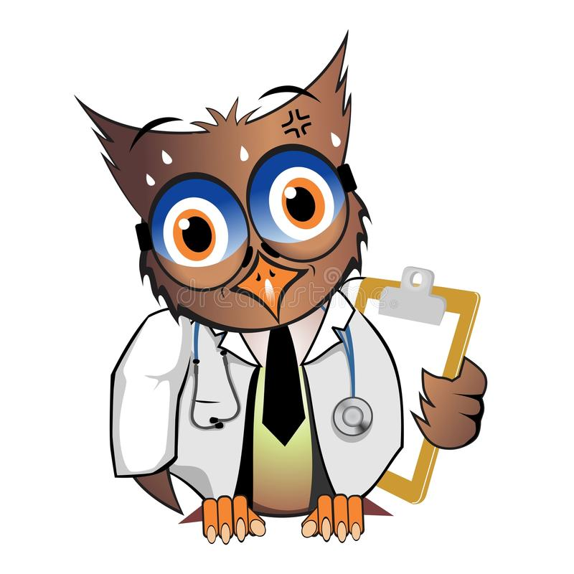

Mummy and daddy bear did not know why Eddie was hurt inside.



Dr Owl rang Paula Penguin for help; Paula Penguin helped lots of bears and knew how best to look after little cubs.

Paula Penguin knew that little bears needed to be cared for gently and calmly so that their little bodies did not get hurt, and that they needed to be kept safe.



Paula Penguin asked mummy and daddy bears if they knew someone that could help look after the little bears.

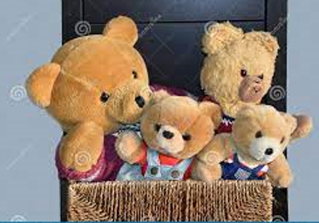
Eddie and Earnie went to live with Aunty Bella and Uncle Bob.
Uncle Bob and Aunty Bella loved the two cubs to the moon and back.

They wanted to look after the little cubs very much, but they found it very tiring.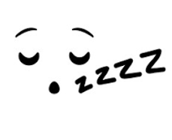
Uncle Bob and Aunty Bella wanted to keep the little cubs safe; they didn’t think they had the energy for the little cubs therefore they asked Paula Penguin if she could find someone else to look after the two little cubs.
Who would look after the little bears? Paula Penguin needed help; she went to see Edward Elephant. Edward was a wise Elephant who had helped other animals; he would know what to do.
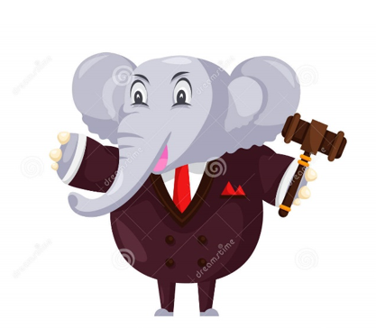
Edward knew that sometimes mummy and daddy bears found it difficult to look after busy little bears, and that sometimes they needed help and lessons on how to play gently and keep little bears safe so that they did not get hurt.
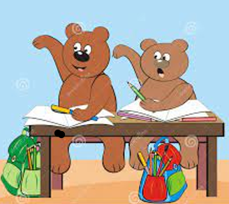
Edward Elephant wanted Eddie and Earnie to be safe. Therefore, while mummy and daddy went to learn about looking after little bears, he asked Paula Penguin to find a safe and caring home for the cuddly bears.



Paula Penguin knew just the place for Earnie and Eddie, she would take them to live with Paul and Penny Panda. They had looked after lots of different bears and knew how to be gentle with baby bears.
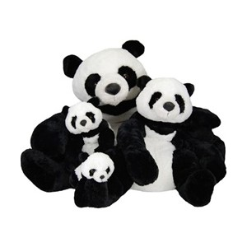
Mummy and daddy bear decided that to look after their little bears safer they needed to live in different houses.
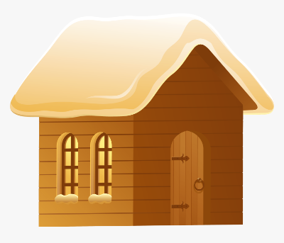
mummy bear’s house
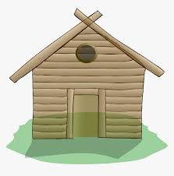
daddy bear’s house
Mummy bear continued with her lessons until one day Edward Elephant felt it was safe for the two little bears to return home. He asked Paula Panda to help the little bears settle back in with mummy bear.


Daddy bear had also learnt about how to be kind and gentle to help little bears grow. Therefore Edward Elephant felt he could now visit the little bears.

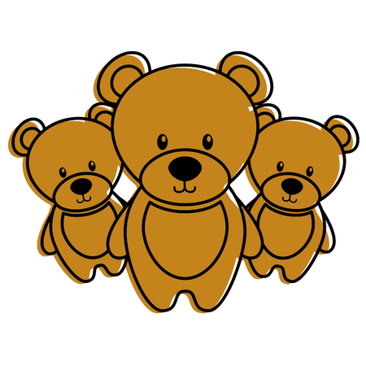

Mummy bear was so glad to have her little bears at home; she gave them a big cuddle and told them that she would keep on learning on how to be a good, gentle and caring mummy bear.

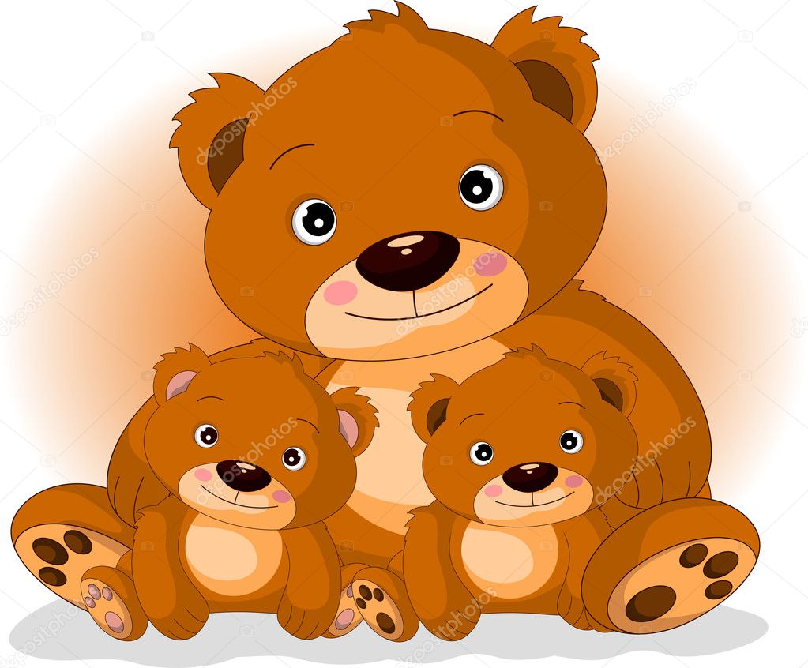
Mummy bear now knew that she and her little bears would always need help to make sure that the little cubs grew up to be strong, gentle and kind bears, and how important it was that they all had other gentle and kind animals in their lives to help them.
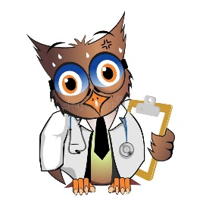

The END

