Book List for Adopters:
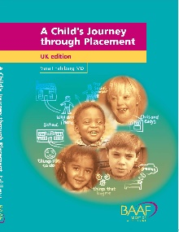
A Child’s Journey through Placement
by Vera Fahlberg

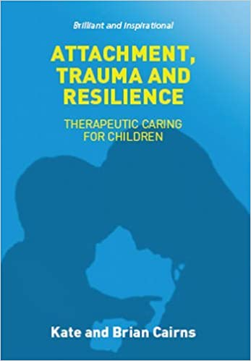
Attachment, Trauma and Resistance
by Kate Cairns

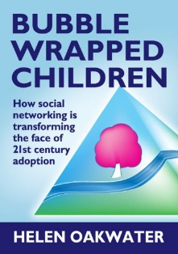
Bubble Wrapped Children
by Helen Oakwater

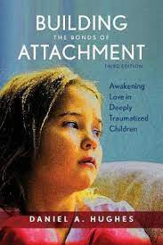
Building the Bonds of Attachment
by Daniel Hughes

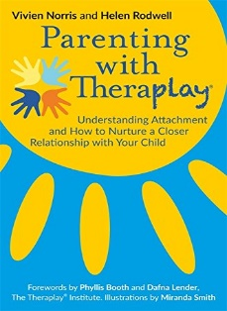
Parenting the Theraplay Way
(Purchase through Adoption UK)

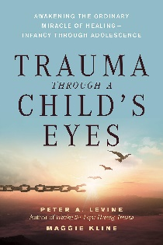
Trauma through a child’s Eyes
by Peter Levine

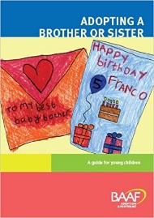
Adopting a brother or sister
by Heidi Argent

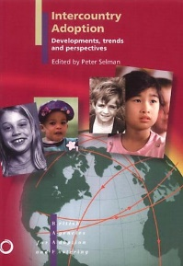
Inter Country Adoption -
Developments,
Trends and Perspective
by Peter Selman
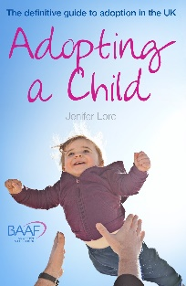
Adopting a Child (9th edition)
by Jennifer Lord

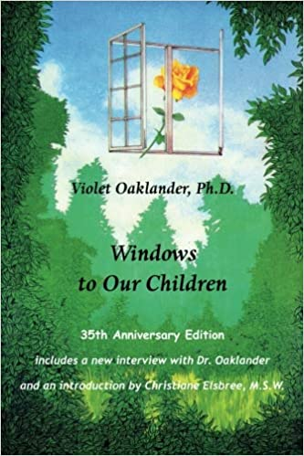
Windows to our Children
by Violet Oaklander

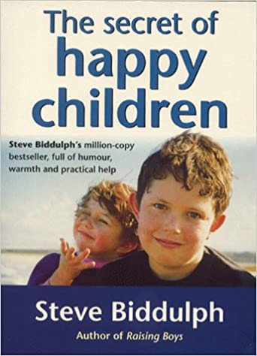
The Secret of Happy Children
by Steve Biddulph

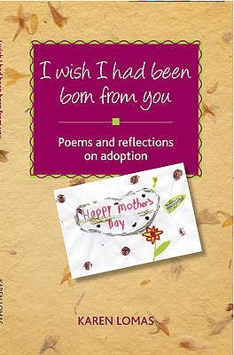
I wish I had been born from you
by Karen Lomas

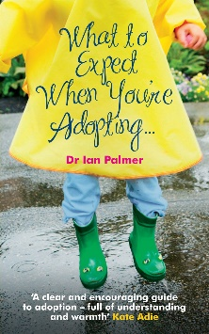
What to expect when you’re Adopting –
a practical guide to the decisions and
emotions involved in adoption
by Dr Ian Palmer
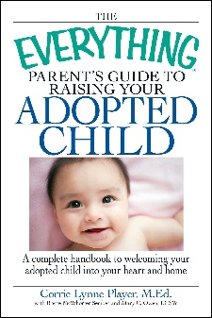

The everything parent’s guide to raising
your adopted child:
a complete handbook to welcoming
your adopted child into your heart and home
by Corrie Lynne Player with Brette McWhorter Sember and Mary C. Owen.

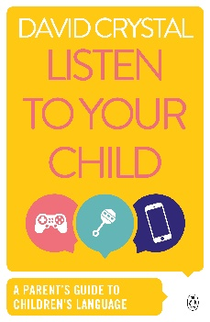
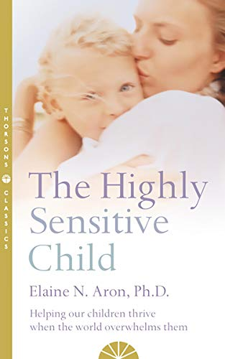

Listen to your child-
a parent’s guide to children’s language
by David Crystal

The Highly sensitive child:
Helping our children thrive
by Elaine N Aron

Websites for Adopters

http://corambaaf.org.uk/ - This organisation offers a wide range of information with regard to adoption.

http://www.adoptionuk.org/ - This organisation offers guidance for adoptive parents and those who are interested in adoption.

http://www.adoptcymru.com/home/ - (Wales’) National Adoption Service

http://www.westernbayadoption.org/our-children/ - Western Bay Adoption Service

Personal Accounts of Adoption

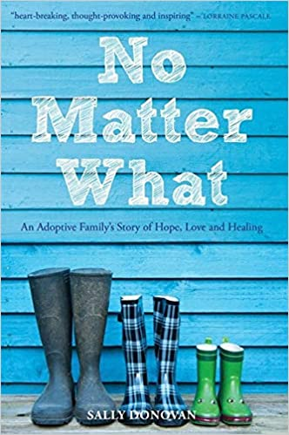
No Matter What: An Adoptive Family’s Story
of Hope, Love and Healing
By Sally Donavan

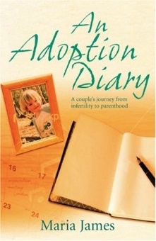
An Adoption Diary
By Maria James

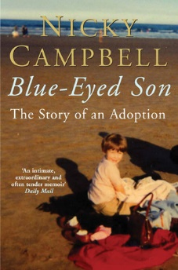
The Story of an Adoption
By Nicky Campbell

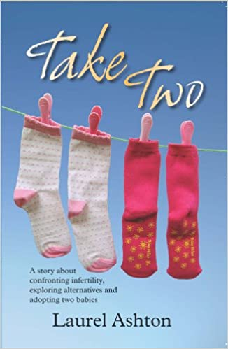
Take Two: A story about confronting infertility,
exploring alternatives and adopting two babies
By Laurel Ashton

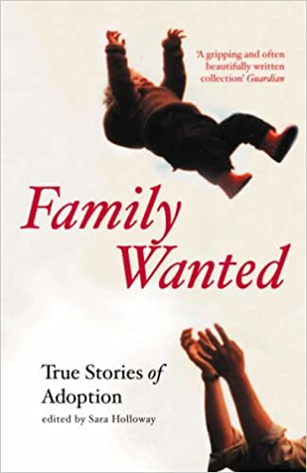
Family Wanted:
Stories from adopters/birth families and adoptees
By Sara Holloway

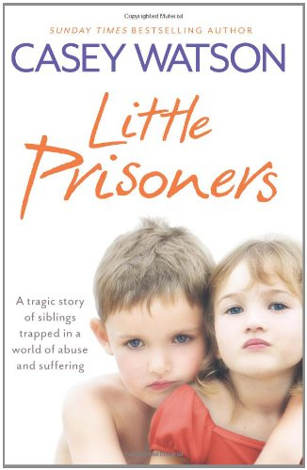
Little Prisoners:
A tragic story in a world of abuse and suffering.
By Casey Watson

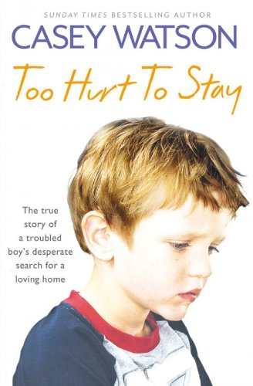
Too Hurt to Stay:
The true story of a troubled boy’s
desperate search for a loving home
By Casey Watson

Novels and Films
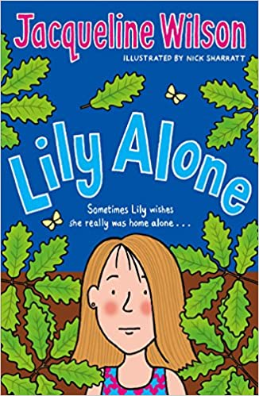
Lilly Alone
by Jacqueline Wilson

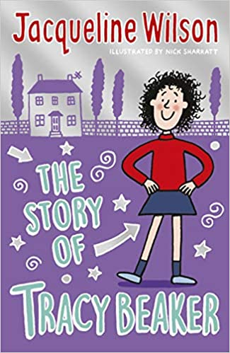
The Story of Tracey Beaker
by Jacqueline Wilson

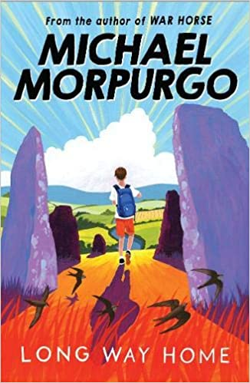
Long way Home
by Michael Morpurgo

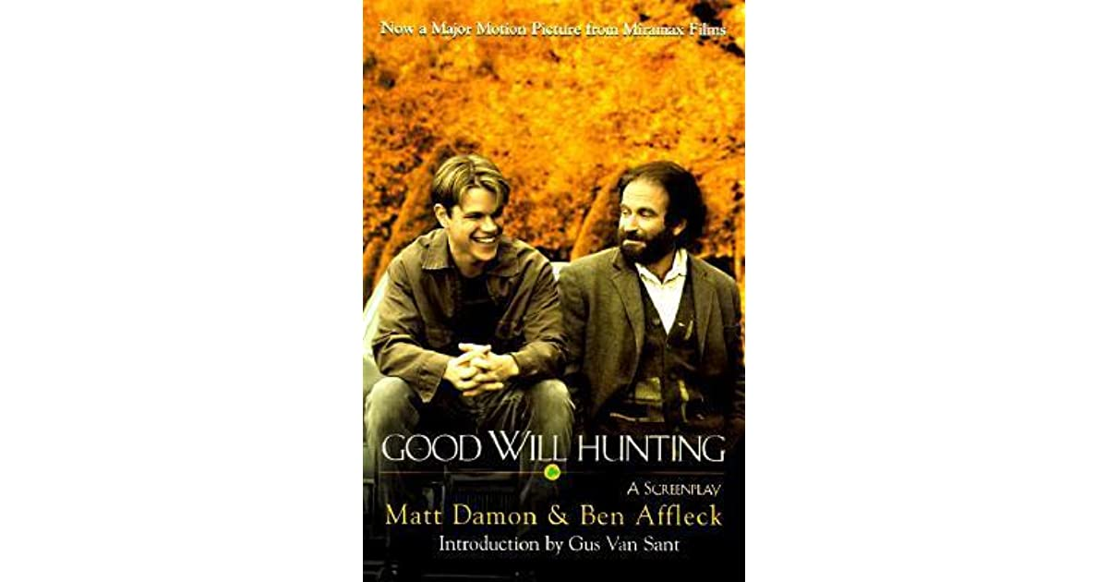
Good Will Hunting
by William Goldman

Inside Out (Disney Pixar)

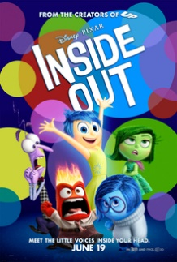

Films for children

Themes of different types of families, adoption, different paths to adoption:

- Stuart Little https://www.youtube.com/watch?v=Wlo-sYrADlw

- Kung Fu Panda https://www.youtube.com/watch?v=PXi3Mv6KMzY

- Box trolls https://www.youtube.com/watch?v=Q2dFVnp5K0o

- Secret Life of Pets https://www.youtube.com/watch?v=-yPuWcCykNk

- Despicable Me https://www.youtube.com/watch?v=_RJsoyU28hk

- Annie (New) https://www.youtube.com/watch?v=O-lw0Jtmzn8
(Old) https://www.youtube.com/watch?v=Tg7JWB2SR7E

- Lion King https://www.youtube.com/watch?v=lFzVJEksoDY

- Inside Out https://www.youtube.com/watch?v=WIDYqBMFzfg

- Matilda https://www.youtube.com/watch?v=pnzLRDDijW0

