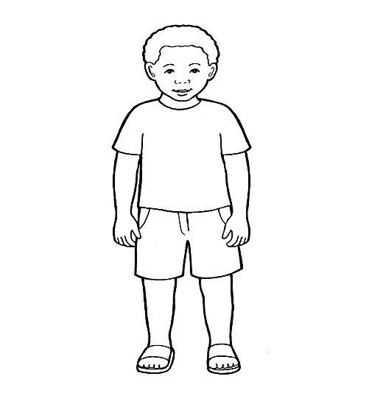

MY LIFE WITH MY

BIRTH FAMILY

To My Birth Parents,

Please record here all the information that you remember about our life together, before I went into care.
The purpose of this book is to help me understand my life whilst living with yourselves and to make sense of the circumstances that led to me coming into foster care.
Thank you!

My Life with My Birth Family

Contents

1. My birth parents and my birth

2.My life with my birth parents

3.Why I could no longer live with my birth family

4. Photographs

1.My birth parents and my birth

A birth family is the family you have when you are first born.

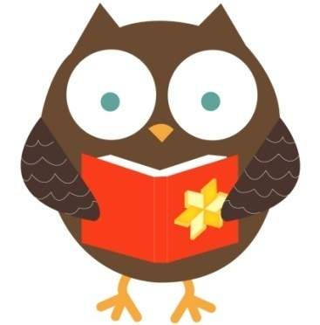

Everyone has a birth mum and a birth dad, even if they don’t see them or live with them.

What are your names and do they have any special meaning?

How was your life like before becoming a family together? What about your school, childhood and jobs?

How and where did you meet? How was your relationship like?

How many children did you have and what were their names?

Where did you live? Who lived with you in the house?

What memories do you have from before I was born? Was my birth mother healthy whilst being pregnant and were there any significant events during the pregnancy?

When and where was I born? What day of the week it was? Did I arrive on time or not? How was the birth? What about my weight and health at birth?

What name did you choose for me and why?

2. My life with my birth parents

Families come in all different shapes and sizes. This is the story of …….’s life with birth
parents………. and ……….. Like all stories, it has happy parts and not so happy parts.

Where and who did I live with? Can you describe the house I lived in and all the people I lived with?

Where there any other family members I used to see? What were their names and where did they live?

Did my birth family think I looked similar to any particular family member? If so, in which way ? What about personality, likes and dislikes? Any similarities there?

How was my sleep routine when I lived with my Birth Parents? ?

What comforters did I use for going to sleep and for when I became upset or sad?

How was I feeding and who did usually feed me ?

Were there any significant events in my life which my birth family can remember and talk about?

What do you remember about my bath time? Who used to bath me, did I enjoy it, did I have favourite bath toys?

When did I have my first tooth and which tooth came out first? How was I during the teething months as a baby?

How old was I when could I sit up
unaided for the first time ?

What age was I when I started to crawl?

When did I first stand alone, with no help ?

When did I take my first steps without any help ?

When and where did I get my first pair of shoes?

What were my first words and when did I say them? What do you remember about the time when I started babbling, speaking and singing?

Did I prefer to pick objects up with my left or my right hand?

When did I start using a feeder cup by myself and what was my favourite drink?
What solid food did I first have and how did I enjoy that? What were my favourite meals and when did I start eating by myself?

What were my favourite toys and games ?

What age was I when I first could ride a scooter or a bike? Who helped me learn how to ride them?

Did I enjoy swimming and if so, who used to take me swimming?

What books did I enjoy being read to me and who used to read my bed time story? Did I have a favourite character?

How did I get on with becoming more
independent such as washing/getting dressed/eating by self?
What about potty training?

Did I have any favourite foods, games, toys?

Who in the family I spent more time with and who mostly cared for me?

Did you think I looked similar to any particular family member? If so, in which way ? What about personality, likes and dislikes? Any similarities there?

Did I go to any childcare/nursery or school ? If so, where did I go? What do my birth family remember about me going to school or nursery? Did I enjoy it and did I make friends?

What about my teachers in school/nursery? What were their names and what were my favourite
teachers?

Did you have any pets? If so, what were their names and what was my relationship with them like?

What were my favourite
activities/sports/hobbies as I was growing up? What did you think of how well I did in some of these activities?

Were there any significant events in my life which my birth family can remember and talk about?

What about any anecdotes and funny things you remember about me from when I lived with you?

4. Photographs

Please insert here pictures of everyone within the family, the house we lived in, things we did together, special events and celebrations. These pictures will help me to remember my life before coming into care and to keep these memories alive.

Thank you!

Figure 1 Insert pictures here

Figure 2Insert comments here

Figure 3Insert pictures here

Figure 4 Insert comments here

